Lowercasing and Uppercasing

Definition
# Source: AI Source: Provided by: [Data Path: Persons Table -> ID Column: 1, Name_En Column: Motasem Essam] -> From: [ChatGPT] on [12/10/2025]
Lowercasing and Uppercasing are simple text transformation techniques that convert all letters in a text to either lowercase or uppercase. This is done to standardize text for analysis, ensuring consistency and avoiding duplicates caused by differences in letter case.

Key Idea
# Source: AI Source: Provided by: [Data Path: Persons Table -> ID Column: 1, Name_En Column: Motasem Essam] -> From: [ChatGPT] on [12/10/2025]
In text data, "Apple" and "apple" are considered different tokens if case is not standardized. By converting text to lowercase (or uppercase), all variations are treated consistently, which simplifies processing and analysis.

How It Works
# Source: AI Source: Provided by: [Data Path: Persons Table -> ID Column: 1, Name_En Column: Motasem Essam] -> From: [ChatGPT] on [12/10/2025]
- Lowercasing: Converts all characters to lowercase.
Example: "Machine Learning is Fun" → "machine learning is fun"
- Uppercasing: Converts all characters to uppercase.
Example: "Machine Learning is Fun" → "MACHINE LEARNING IS FUN"

Example
# Source: AI Source: Provided by: [Data Path: Persons Table -> ID Column: 1, Name_En Column: Motasem Essam] -> From: [ChatGPT] on [12/10/2025]
Original text:
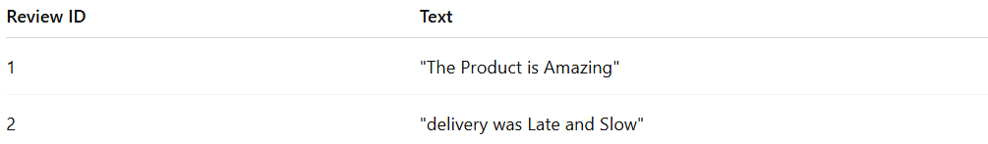
Review ID | Text
1 | "The Product is Amazing"
2 | "delivery was Late and Slow"
After Lowercasing:
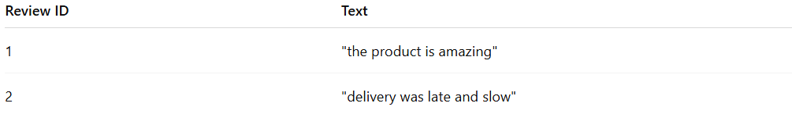
Review ID | Text
1 | "the product is amazing"
2 | "delivery was late and slow"
After Uppercasing:
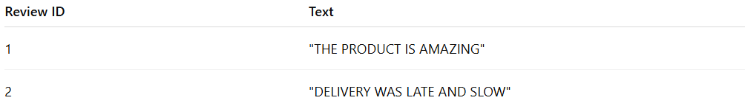
Review ID | Text
1 | "THE PRODUCT IS AMAZING"
2 | "DELIVERY WAS LATE AND SLOW"

Advantages
# Source: AI Source: Provided by: [Data Path: Persons Table -> ID Column: 1, Name_En Column: Motasem Essam] -> From: [ChatGPT] on [12/10/2025]
- Reduces duplicate tokens caused by letter case differences
- Simplifies text preprocessing for NLP tasks
- Improves consistency for tasks like tokenization, counting, and vectorization

Disadvantages
# Source: AI Source: Provided by: [Data Path: Persons Table -> ID Column: 1, Name_En Column: Motasem Essam] -> From: [ChatGPT] on [12/10/2025]
- Can remove contextual information in cases where capitalization matters (e.g., proper nouns like "Apple" the company vs "apple" the fruit)
- Not sufficient alone for cleaning text; often combined with tokenization, stopword removal, and stemming

